Friday 7th May 2021

Dear Parents
What a busy week! Where does the time go? Both classes are busy learning and becoming fully involved in the topics for this Summer Term. Class One are ‘Saving our Seaside’ and Class Two are linking their learning to Africa.
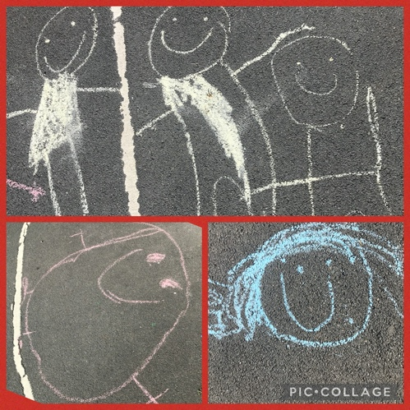
Class One
Very busy outside with this delightful art work. Miss Harper and Mrs Reynolds were both impressed with the children this week and how well they have adapted to the changes.
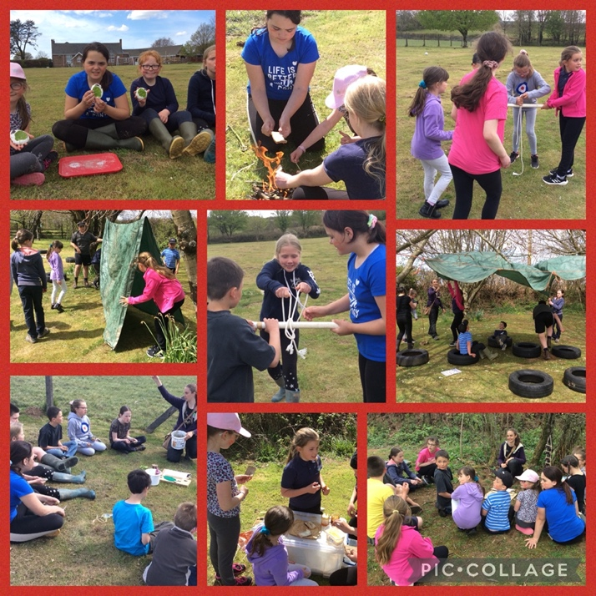

Wild Tribe for Class Two
Class Two worked with the Kayleigh, the ranger from Arena, all day on Friday and completed so many interesting activities. The weather was stunning and perfect for the children to participate all day outdoors. A perfect lead into…

Mental Health Awareness Week
Mental Health Awareness Week this year has a focus on nature. 45% of us reported being in green spaces had been vital for our mental health throughout recent lockdowns. Wider studies also found that during lockdowns, people not only spent more time in nature but were noticing it more. We can recommend reading this insightful article The Positive Effects of Nature on your Mental Wellbeing for gaining an in depth understanding of this area. There are lots of simple ways to bring nature into your everyday life.
We will be sharing our thinking with the children during our PSHE and assembly sessions. We are so lucky to be living in such a green space.

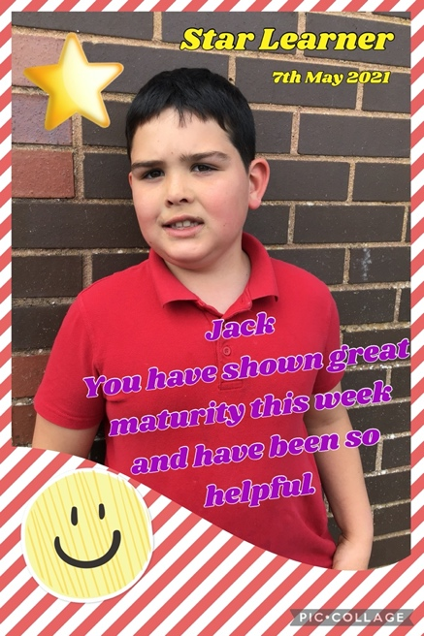
Star Learners
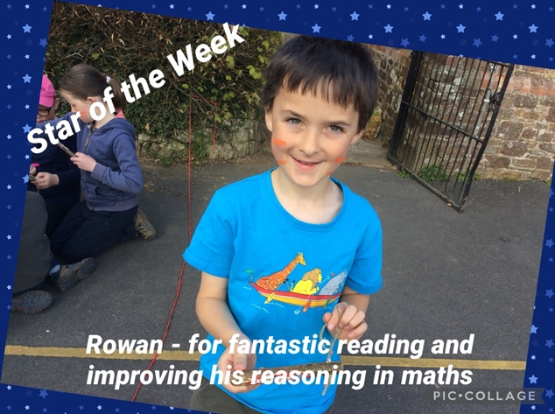
Class One This week, Jack has shown such great maturity in the absence of Mrs Tothill. He has been incredibly helpful and kind. Well done Jack!
Class Two
Rowan in Class Two demonstrated his super reading ability. Miss Southam has also seen a great improvement in his Maths reasoning. Well done Rowan!

Weekly Update
There are a number of Governor vacancies and every parent was sent an individual email with full details. Please do get in touch if you are interested in applying or follow the link below.
To apply, please complete the form linked here and available from the Trust website ‘Join Us’ page here https://www.dartmoormat.org.uk/governance.html. Completed nomination forms must be completed online by Friday 18th June 2021.
With many thanks for your support
Miss Sunita Chauhan

Diary Dates
Monday 17th May – Virtual Parents Evening. Please make your bookings
Friday 21st May 1:3pm – FOBS Meeting
Monday 31st May to Friday 4th June – Half Term
Tuesday 13th and Wednesday 14th July – transition day for year 6 to HCC
Friday 16th July – provisional date for Sports Day TBC
Friday 23rd July – last day of term

